|  |  |  |  |  |  |  |
| --- | --- | --- | --- | --- | --- | --- |
| **REVISION HISTORY** | | | | | | |
| Revision | Description of Change | | Writer/Reviser | | Effective Date | |
| 0.1 | Initial Version | | Barry Robertson | | 1/29/2015 | |
|  |  | |  | |  | |
|  |  | |  | |  | |
|  | | | | | |
| Author Name | | Title | | Department Name | |
| Barry Robertson | | OpenXC Modem Connect PC App Build Instructions | |  | |

**APPROVERS**

|  |  |  |  |  |
| --- | --- | --- | --- | --- |
| Name | Title | Department | Approval Status | Approval Date |
| Barry Robertson | Software Engineer |  |  |  |
|  |  |  |  |  |
|  |  |  |  |  |
|  |  |  |  |  |
|  |  |  |  |  |
|  |  |  |  |  |

**ABOUT FLEXTRONICS**

Flextronics is a leading Electronics Manufacturing Services (EMS) provider focused on delivering complete design, engineering and manufacturing services to automotive, computing, consumer, industrial, infrastructure, medical, clean tech and mobile OEMs. Flextronics helps customers design, build, ship, and service electronics products through a network of facilities in 30 countries on four continents. This global presence provides design and engineering solutions that are combined with core electronics manufacturing and logistics services, and vertically integrated with components technologies, to optimize customer operations by lowering costs and reducing time to market.

Table of Contents

1 Introduction 3

1.1 Scope and Purpose of the document 3

1.2 Intended Audience or Applicability 3

1.3 References 3

2 Build Process 3

3 Review Checklist 5

# Introduction

This document describes how to build the OpenXC Modem Connect PC application that is used to detect OpenXC Modem connectivity to the PC and open or close Teraterm (or other configured terminal application) on the proper port automatically.

## Scope and Purpose of the document

This document discusses build and packaging of the OpenXC Modem Connect PC application using Microsoft Visual Studio. Note: Microsoft Visual Studio 2008 Pro was used.

## Intended Audience or Applicability

The intended audience for this document is the software team for the OpenXC project.

## References

None.

# Build Process

The following steps occur on a Windows PC with Microsoft Visual Studio 2008 Pro (or equivalent).

* Open the project solution file:  
  OpenXC\SVN\PC_Config\ModemConnect\ModemConnect.sln
* Make changes (as required) for any new software features.
* If any changes were made to the software, check the files into SVN.
* Make note of the SVN revision number for the OpenXC repository – this will be used to update the version of the application.
* **NOTE: The following steps build the application and may update some project files to set version information; these updates should be discarded after the build to prevent someone from building another copy of the software with the same version.**
* In the Solution Explorer, select the “ModemConnect” project, then in the main menu bar, select Project / ModemConnect Properties.
* Under the “Application” tab, select the “Assembly Information” button.
* Update the last field of the assembly version number (shown here as 143) with the new SVN version number, and select OK.  
  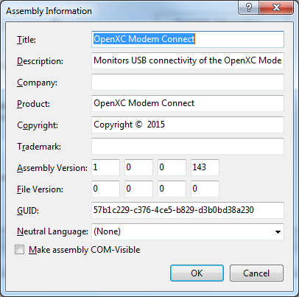
* In “Solution Explorer” on the right panel (or as configured), right click on “ModemConnect” and select “Rebuild”.
* Next, in “Solution Explorer” right click on “ModemConnect Installer” and select “Properties”.  
  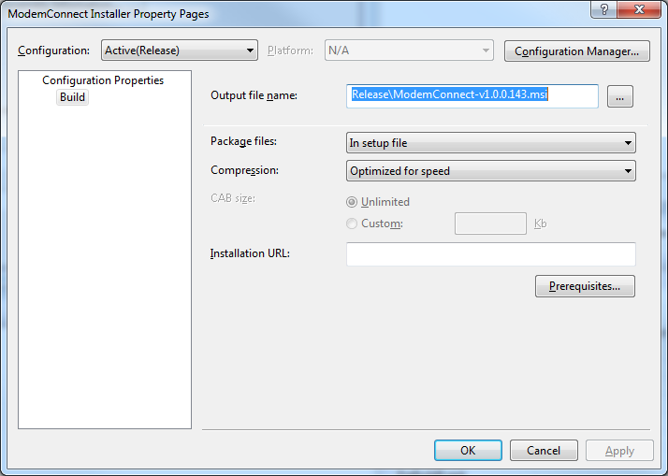
* Update the version number of the “Output file name” to use the new version number and select OK.
* Right click on “Modem Connect Installer” and select “Rebuild”.
* Go to the OpenXC\SVN\PC_Config\ModemConnect\Setup\Release directory and copy the new .msi file to the OpenXC\SVN\PC_Config\ModemConnect\builds directory
* Test the installation file and OpenXC Modem Connect application by installing, uninstalling, etc…

# Review Checklist

This document should be reviewed using the below checkout.

|  |  |  |  |  |
| --- | --- | --- | --- | --- |
| **Number** | **Checklist Item** | **Reviewer Name** | **Reviewed Yes/ No** | **Review Comments** |
|  |  |  |  |  |
|  |  |  |  |  |
|  |  |  |  |  |
|  |  |  |  |  |
|  |  |  |  |  |
|  |  |  |  |  |
|  |  |  |  |  |